ASSIGNMENT 1

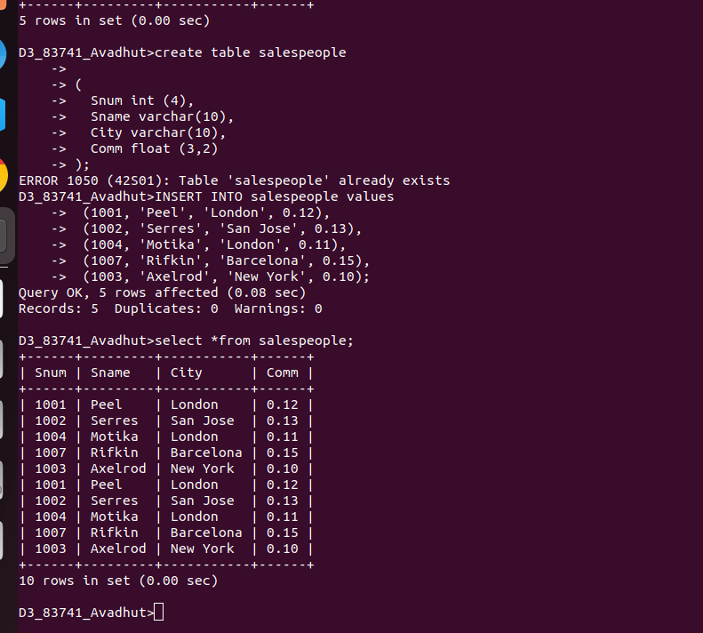
Q1. Create SALESPEOPLE table and insert values.

Q2. Create CUSTOMERS table and insert values.
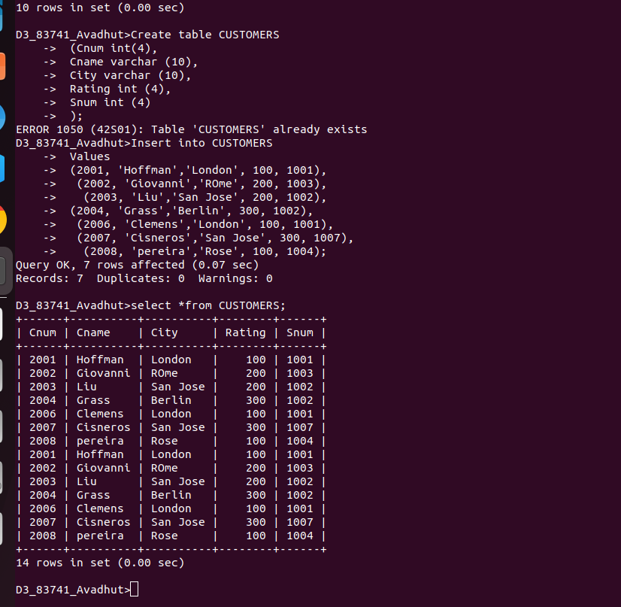

Q3. Create ORDERS table and insert values.
